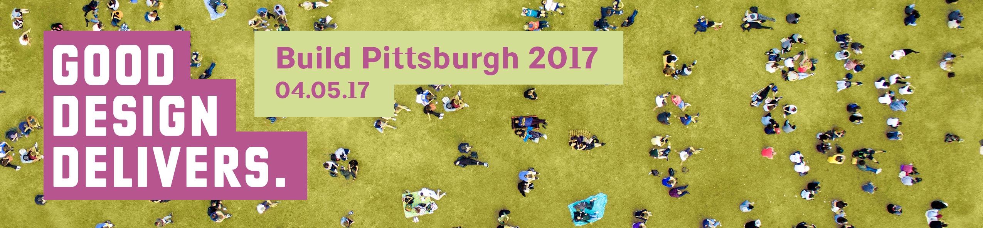

SAMPLE E-NEWSLETTER COPY:

Build Pittsburgh 2017
April 5, 2017 – David L. Lawrence Convention Center, Pittsburgh

Good Design Delivers.

Join us and AIA Pittsburgh on Wednesday, April 5th for Build Pittsburgh 2017, AIA Pittsburgh’s annual continuing education conference and exhibitor show.

We invite architects, engineers, owners, and all design professionals to join us for a full day of continuing education. Be a part of the conversation and collectively learn just how good design delivers sustainable, safe, equitable, and diverse communities.

VISIT aiapgh.org to learn more.
VIEW the presenters & programming.
REGISTER today! Early bird discounts available until March 15th!

Members of AIA, GBA, CSI, MBA, and AIA Pittsburgh Industry Partners receive member pricing.
Earn AIA/CES Learning Units and GBCI CEUs.
Explore New Products & Services at the Exhibitor Show!
The Build Pittsburgh 2017 Exhibitors will be available throughout the day to show you their latest products and services.
Learn more: http://aiapgh.org/aia-programs-events/build-pittsburgh/
SAMPLE FACEBOOK POSTS:
We are excited to join AIA Pittsburgh on April 5th for Build Pittsburgh 2017, AIA Pittsburgh’s annual continuing education conference and exhibitor show. Check out the lineup! http://aiapgh.org/aia-programs-events/build-pittsburgh/
Who will you find at #BuildPgh17? Find the course list, presenters, and exhibitors here: http://aiapgh.org/aia-programs-events/build-pittsburgh/ #GoodDesignDelivers
SAMPLE TWEETS and/or INSTAGRAM POSTS:
Will we see you at #BuildPgh17 ? #AIA #Pittsburgh #GoodDesignDelivers @AIAPGH #Education #ExhibitorShow http://ow.ly/6YRK309DdRZ

On April 5th find us @ #BuildPgh17 talking to #architects #engineers & the #design community! #AIA #Pittsburgh http://ow.ly/vClZ309Dcdp @AIAPGH
#Interact #network & #connect with all aspects of the #Pittsburgh #design #build industry! @AIAPgh #BuildPgh17 http://ow.ly/vClZ309Dcdp

