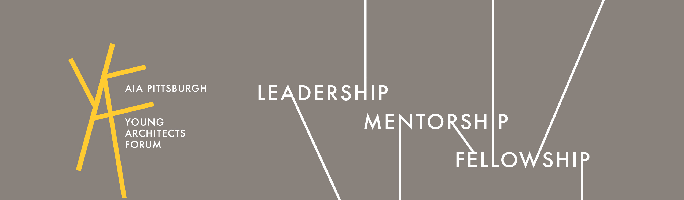

YOUNG ARCHITECTS FORUM | AIA PITTSBURGH | Advisory Committee Minutes of Meeting

This report confirms and records the interpretation of discussions which occurred and the understanding reached during this meeting. Unless notified in writing within seven (7) days of the date below, it will be assumed that the following interpretation or description is complete and accurate without exception.

MEETING NO.: | MEETING DATE: | TIME: | MEETING LOCATION:
2016-04 | Wednesday, May 25th, 2016 | 5:30 – 6:40 PM  [1 HR – 10 MINS] | AIA Pittsburgh Offices  The Bruno Building | 945 Liberty Avenue, 3rd Floor

PARTICIPANTS:
NG | Nicole Graycar, AIA | Chair | ngraycar@andrew.cmu.edu
RB | Ray Bowman, Assoc. AIA | Vice Chair | ray.bowman@gmail.com
IG | Ilana Gutierrez, Assoc. AIA | Secretary | igutierrezvelez@gmail.com
BS | Bea Spolidoro, Assoc. AIA | PR Director | beaspoli@gmail.com
JA | Joe Adiutori, Jr., Assoc. AIA | Communications Chair | jja5055@gmail.com
NGr | Natalie Grandinetti | AIA Pgh MM+C | ngrandinetti@aiapgh.org
RK | Rachel Kelley | AIA Pgh | rkelley@aiapgh.org
BG | Brian Gaudio |  | bgaudio@ncsu.edu
JG | Jenna Glover |  | Julove10@kenr.edu
M | Michael |  | Zskwara@kent.edu
A | Alexis |  | adorko@kent.edu
S | Sara |  | sechodkowski@gmail.com

AGENDA ITEMS:
- Recap Past Events: Build PGH / YAF Tailgate / AIA Convention / Rycon Tour / Desmone Tour
- Upcoming Scheduled Summer Events
- Planning for the second half of the year

UPCOMING EVENTS:
- ARE Planning Session: June 1st
- ACE Pirates Game: June 8th ($20 Donation)
- CANpletion: Team Awards Event (Mall at Robinson): June 10th
- CRAN Event: Mary Cerrone’s House- Q3/4 (Fall)
- Three Rivers Art Festival June 3rd -12th
- GBA 2030 Goals Sessions: June 21st & 23rd

MEETING TOPICS:
- Business cards design was updated by our Graphic Designers; Jiayu & Ilana coordinate with specs
- Building Tours:
  - Phoenix Apartments: September
  - Heinz Lofts Building Tour- Fall 2016; Bill Charles
  - Building Tour(s) w/ IKM, Inc. - TBD. Contact: Tami Greene
- Joe Skibba – Workshop about arch renderings, drawings and sketching TBD- tools and techniques
- YAF Graphics- Updated header / Logo / Header was added! (Same graphics, updated look)
- YAF Membership- Firm by Firm campaign a possibility
  - Informal Meeting
  - Meeting & networking with local architects
  - Firm happy hour- responsible min drinks and food
  - June 15th Firm Visit at Strada
- PLI Bulletin - Tell your colleagues, and let us know if you have any comments or concerns...
  - http://aiapgh.org/aia-community/city-of-pittsburgh-department-of-permits-licenses-and-inspections/
- Firm Happy Hours - Local Firm to host YAF to highlight firm culture, studio space and projects. Firms to sponsor event. Opportunity for informal networking/soft interviewing.
- Design Pittsburgh - opportunity for members to showcase their projects. (Gallery Crawl Sept. 23, PKN Oct. 6, Gala & Award Ceremony Oct. 27) Interested? Contact Rachael to join the Design Pittsburgh Committee or attend the brainstorming session (date tbd). rkelley@aiapgh.org

LINKS:

Columns Home Page:
http://aiapgh.org/columns-home/

AIA Events Calendar:
http://aiapgh.org/events/

Green Building Alliance
https://www.go-gba.org/

“The nature of space reflects what it wants to be.” LOUIS KAHN

END OF DOCUMENT

